The Talbott Springs Elementary School Flu Shot Clinic will be on Monday October 31st.
This Flu Shot Clinic is for Talbott Springs Students and Staff only.
The Vaccine being given, is single dose syringes of quadrivalent, preservative free Flu vaccine.

All students and staff must be preregistered to receive the vaccine.
Registration is open now and will close end of day on October 24th.
Please Register through the following link:
https://www.marylandvax.org/appointment/en/reg/9912605079

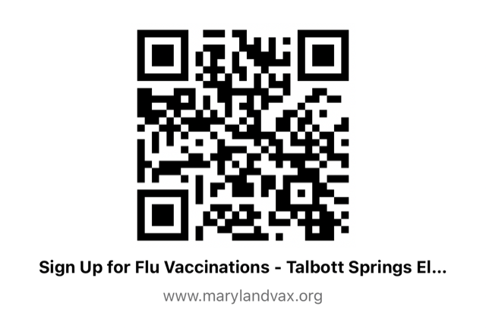
Please contact Lindsey Squillario, RN with any questions. She can be reached at 410-313-6918 or at lindsey_squillario@hcpss.org

